Run Score Schema

Project Purpose
This project is a running recommendation application that helps users determine the best time to run outdoors based on weather and air quality conditions.
Key objectives:
• Determine the best time of day to run
• Recommend indoor versus outdoor workouts
• Calculate a weighted Run Score
• Display the Top 3 Run Times for a selected day
• Store weather and air quality data for historical analysis
• Provide an interactive analytics dashboard

ER Diagram
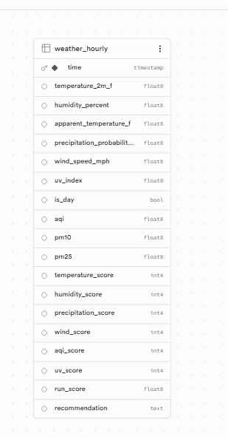

Technical Architecture
User Browser
↓
Browser Geolocation
↓
Open-Meteo Forecast API
Open-Meteo Air Quality API
↓
ETL Pipeline
(Extract → Transform → Validate → Load)
↓
PostgreSQL Database (Supabase)
↓
Dash Dashboard
↓
Recommendations & Visualizations

Database Design
Database: PostgreSQL (Supabase)
Main Table: weather_hourly
Primary Key:
• time
The time field uniquely identifies each hourly forecast record and supports incremental UPSERT loading to prevent duplicate records.

Schema Definition
CREATE TABLE weather_hourly (
time TIMESTAMP PRIMARY KEY,
temperature_2m_f DOUBLE PRECISION,
humidity_percent DOUBLE PRECISION,
apparent_temperature_f DOUBLE PRECISION,
precipitation_probability_percent DOUBLE PRECISION,
wind_speed_mph DOUBLE PRECISION,
uv_index DOUBLE PRECISION,
is_day BOOLEAN,
aqi DOUBLE PRECISION,
pm10 DOUBLE PRECISION,
pm25 DOUBLE PRECISION,
temperature_score INTEGER,
humidity_score INTEGER,
precipitation_score INTEGER,
wind_score INTEGER,
aqi_score INTEGER,
uv_score INTEGER,
run_score DOUBLE PRECISION,
recommendation TEXT)

Normalization
The schema follows Third Normal Form (3NF):
• All columns contain atomic values
• No repeating groups exist
• No partial dependencies exist
• No transitive dependencies exist
A single table is appropriate because the application currently uses one location and one weather source per run.

Data Sources
Open-Meteo Forecast API
• Temperature
• Humidity
• Apparent Temperature
• Precipitation Probability
• Wind Speed
• UV Index
• Daylight Indicator
Open-Meteo Air Quality API
• AQI
• PM10
• PM2.5

ETL Pipeline
Extract
• Retrieve weather data from Open-Meteo Forecast API
• Retrieve AQI data from Open-Meteo Air Quality API
Transform
• Clean data
• Handle missing values
• Convert timestamps
• Merge weather and AQI datasets
• Calculate scoring metrics
• Generate recommendations
Validate
• API response validation
• Null checks
• Duplicate detection
• Schema validation
• Range validation
• Load verification
Load
• PostgreSQL via SQLAlchemy
• Incremental UPSERT strategy
• Prevent duplicate records

Run Score Logic
Temperature: 25%
Humidity: 20%
Precipitation: 20%
Wind Speed: 15%
AQI: 15%
UV Index: 5%
Total Weight = 100%

Temperature Scoring
<32°F = 30
32–39°F = 60
40–49°F = 85
50–65°F = 100
66–75°F = 80
76–85°F = 55
>85°F = 25

Humidity Scoring
<55% = 100
55–60% = 85
61–65% = 70
66–70% = 50
>70% = 20

Precipitation Scoring
0–10% = 100
11–30% = 85
31–50% = 60
51–70% = 35
>70% = 10

Wind Scoring
<10 mph = 100
10–15 mph = 80
16–20 mph = 60
21–30 mph = 35
>30 mph = 10

AQI Scoring
0–50 = 100
51–100 = 80
101–150 = 45
>150 = 10

UV Index Scoring
0–2 = 100
3–5 = 85
6–7 = 65
8–10 = 40
>10 = 20

Recommendation Categories
90–100 = Perfect Conditions for Outside
50–89 = Outside Recommended
30–49 = Short Outdoor Activity Only
0–29 = Indoor Workout Recommended
The recommendation engine excludes 10 PM through 3 AM when determining the best running times to improve real-world usability.

Dashboard Features
KPI Cards
• Best Run Score
• Best Run Time
• Top 3 Run Times
• Indoor/Outdoor Recommendation
Visualizations
• Run Score Over Time
• 7-Day Temperature Forecast
• Weather Factor Breakdown
Interactivity
• Date Filter
• Browser Geolocation
• Refresh ETL Button

Business Value
This dashboard helps runners make better exercise decisions by combining weather and air quality data into a single recommendation score.
Benefits:
• Reduces weather-related guesswork
• Identifies optimal running windows
• Highlights environmental factors affecting performance
• Encourages safer outdoor activity decisions

Technical Success Metrics
• ETL Pipeline Success Rate >95%
• Dashboard Response Time <3 Seconds
• Database Load Validation = 100%
• Accurate Top 3 Run Time Recommendations
• Interactive Dashboard Filtering

